# AUTOMATIC IDENTIFICATION SYSTEM (AIS)

**Microsoft Edge**

**WINDOWS 10 v1709**

**AIS-MSU-033-2022**

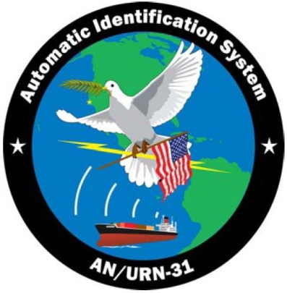

SCIENTIFIC RESEARCH CORPORATION

North Charleston, SC 29406

THIS MSU APPLIES ONLY TO AN/URN-31 (V)1, (V)2, (V)3, AND (V)9 SYSTEMS WITH WINDOWS 10 v1709.

This MSU supersedes MSU-029-2022

## CREATE A BACK UP

## Maintaining an up to date image of the system’s hard drive is a requirement to be able to restore AIS rapidly. Before applying any updates, a full back-up of the original image must be done. Instructions to perform a full back-up can be downloaded from SAILOR. Open a web browser and navigate to https:// sailor.navy.mil; and the From the NAVWAR Programs>Select PEO C4I >Select PMW 120 > Select AIS > Under AIS Content & Downloads Select [System Library >Under](https://sailor.navy.mil/) Documents select Guides > Select Good to Know and the File Name: N65236-AIS-INSTR-0015 Paragon Backup and Restore Instructions Version 06.

## Install Microsoft Edge Update

### Login to the (V)1/3/9 AIS laptop(s) or (V)2 Afloat Server as ais-secman.

### Copy the downloaded update folder to a folder on the (V)1/3/9 AIS laptop(s) or (V)2 AIS Server.

### Uninstall the previous version of Edge.

### Right-click the windows icon (old start), select **Apps and Features**.

### Select **Microsoft Edge**. Select **Uninstall** then **Uninstall** again on the pop-up to confirm.

### In the User Account Control Window, click **Yes**

### Navigate to the update folder. Right click on AIS-MSU-033-2022.zip and select **Extract All**.

### Navigate to the AIS-MSU-033-2022 folder and right-click the **Edge_Install.bat** file and select **Run as administrator**. In theUser Account Control window, click **Yes**.

### If you receive the following message, press any key to exit and repeat step 2.3. Ensure you right click on the Install.bat file and select Run as administrator.

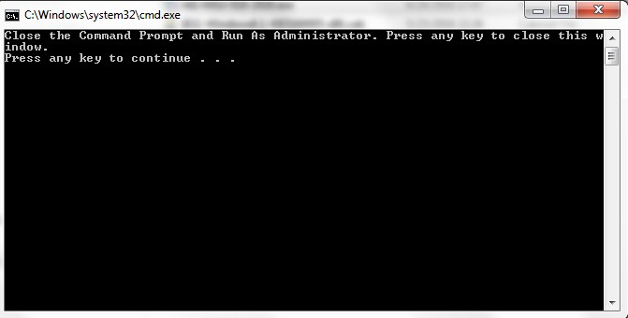

### In the command window, select **1** to install the update.

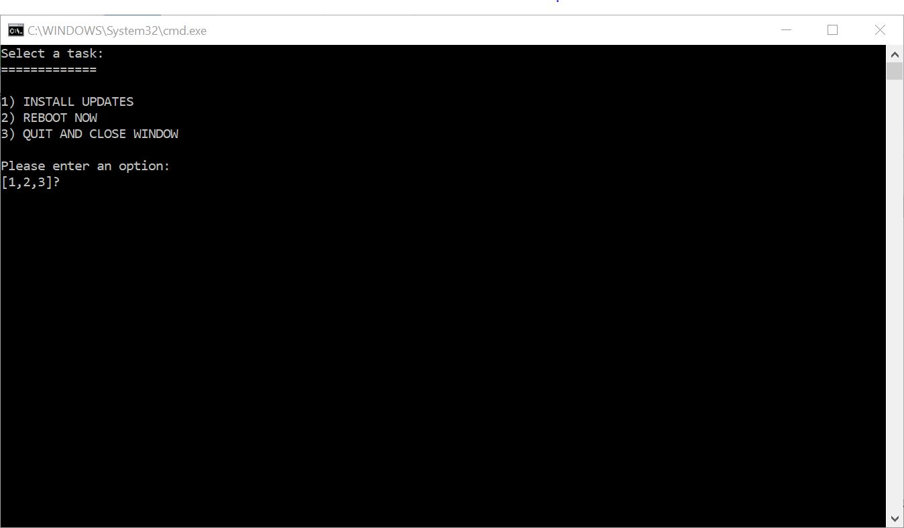

### After the installation, the command window will display the main menu. Press **2** to reboot the computer.

## Verify Installation

### Log in as ais-secman.

### Right-click Start and select **Apps & Features**. On the Apps and Features window, click on **Microsoft Edge**. Verify the version is **106.0.1370.47**.

### On the (V)1/3/9 laptops and (V)2 Afloat Server, open the appropriate documents folder, AIS(V)1Doc, AIS(V)3 (V)9 Docs, or AIS(V)2 Docs. Open an existing .pdf file by double-clicking the file. Verify the document opens in Microsoft Edge.

### **Verify (V)1/3/9 Functionality**

* 1. On the (V)1 **Bridge laptop & (V)3/9 Laptop** ensure Pipeline automatically starts after login.
  2. Launch TV32, ensure you have local contacts being displayed in TV32.

### Verify data is flowing to the MASS in the AIS Pipeline Message window.

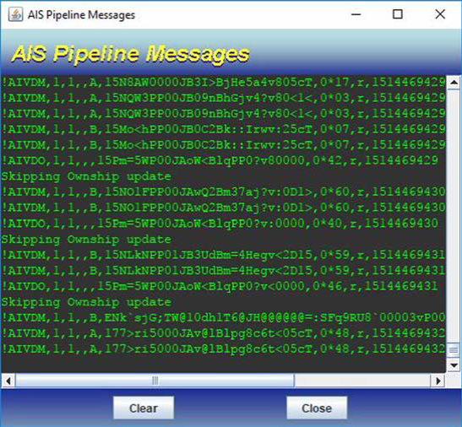

* 1. On the **(V)1 Remote laptop** after login verify Pipeline **does not** automatically start.

### Launch TV32 and verify local contacts are being displayed from the Bridge laptop

### **Verify (V)2 Functionality**

### On the (V)2 server after login double-click the XCOP shortcut on the desktop.

### Right click the XCOP Application icon in the system tray, and hover the mouse pointer over the Tools, then left-click LaunchPad. The Application Started: LaunchPad bubble appears in the system tray area, followed by the XCOP Launcher Hosts Window.

### Click the localhost to highlight it, and click **OK**. The LaunchPad window appears showing all processes running.

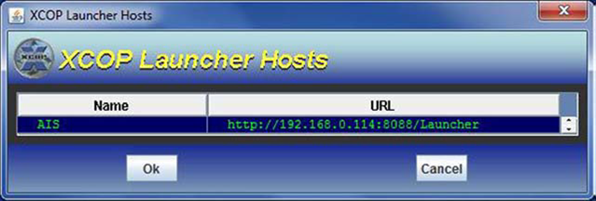

### The LaunchPad window appear. Verify all processes are running.

### On the (V)2 server, right-click the XCOP Application icon, and select the **Console**.

### On the Console login window, click **Ok**.

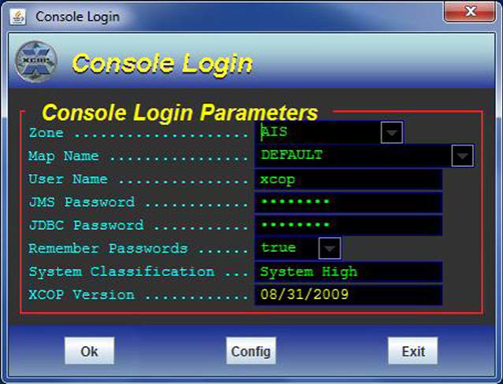

### On the XCOP Track Management Console, verify tracks are populating.

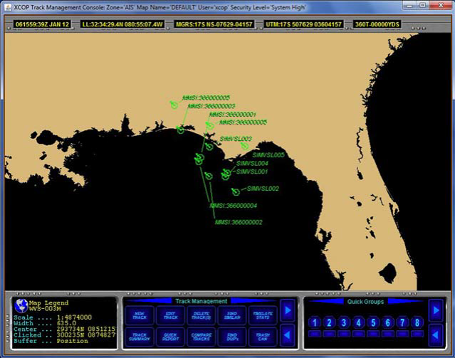

### **AIS-MSU-033-2022 is complete**

### Notify the AIS Software Support Activity via email at: [ais-ssa@us.navy.mil](mailto:ais-ssa@us.navy.mil%20) with subject: AIS-MSU-033-2022 and a brief statement: USS SHIP NAME (HULL-XXX) has installed subject AIS MSU on the AIS Variant (V)1, (V)2, (V)3/9 on DDMMYYYY.

(V)1= Afloat Laptops

(V)2=Afloat Server

(V)3/9=Sub Laptop